Dayalbagh Marriage Panchayat

System Requirements Specification

Version 1.1

Prepared By:
Core Committee- Dayalbagh Marriage Panchayat System

© Copyright DEI, Dayalbagh. 2013 All Rights Reserved

Table of Contents
1 Introduction 3
1.1 Scope 3
1.2 Revision History 3
1.3 Stakeholder Approvers 3
1.4 Reviewers 3
1.5 Glossary 4
2 Requirements 5
2.1 Functional Requirements 5
2.1.1 Functional Requirement 1 - <RRF Creation> 5
2.1.2 Functional Requirement 2 - < Registration Process> Priority- Essential 10
2.1.3 Functional Requirement 3 - <Counseling and Marriage > 13
2.1.4 Functional Requirement 4 - <Registration Cancellation> 16
2.1.5 Functional Requirement 5 - <Registration Renewal> 16
2.1.6 Functional Requirement 6 - <Process Audit and Control> 17
2.1.7 Functional Requirement 11 - <Business Analytics> 17
2.2 Non-Function Requirements 17
2.2.1 Non-Functional Requirement 1 - <Concurrent users> 17
2.2.2 Non-Functional Requirement 2 - <Availability> 17
2.2.3 Non-Functional Requirement 3 - <Data Security> 17
2.2.4 Non-Functional Requirement 4 - <Usability Requirements> 18
2.3 Acceptance Criteria 18
2.3.1 Test Requirements 18
2.4 System External Interface Requirements 18
2.4.1 Report Specifications 18
2.4.1.1 The report layouts will be provide before end of the analysis phase for valid reports Priority -Essential 18
2.5 Assumptions and Issues 18
2.5.1 Assumptions – 18
2.5.2 Issues – 18

Introduction

Scope
This specification establishes the requirements for the Dayalbagh Marriage Panchayat (DBMP)
The DBMP provides the functionality to support the candidates to register and to be a member of the DBMP.

Revision History
All suggestions, comments, and requests for changes to this document should be directed to the President-Dayalabgh Marriage Panchayat

Date of Revision | Version Number | Section Revised | Nature of Revision
18th Dec 2014 | 1.0 | - Entire Document | New Document
23rd Mar 2015 | 1.1 | - Addition of requirements and abbreviations | Feedback Incorporation

Stakeholder Approvers
The following are the Stakeholder Approvers of this Systems Requirement Specification (SRS) document.
Stakeholder Approvers | Representing Area | Date Approved

Reviewers
This section documents the list of people who review this document to verify its completion.
Reviewers | Representing Area
PB. Gurdev Prasad | Functional Requirements

Glossary

- DOB – Date of Birth
- DOI – Date of Initiation
- BS – Branch Secretary
- DS – District Secretary
- SNC – Shiromani Nagar Committee
- EOI – Expression of Interest
- RRF – Request for Registration Form
- RF – Registration Form
- UID – Unique Identity Number
- DBMP – Dayalbagh Marriage Panchayat

Requirements

Functional Requirements

Functional Requirement 1 - <RRF Creation>

For creating the Request for Registration Form (RRF), the candidate is requested to follow below steps:

- Expression of Interest (EOI) for RRF
- Provide Access to RRF
- RRF Form Filling
- RRF Verification
.
2.1.1.1 Expression of Interest for RRF: Priority- Essential
Requester/Candidate fills the prerequisite details such as Name, DOB, DOI, Parents Name and DOI, Branch, Contact details etc. in Marriage Panchayat Online System expressing the interest to access the RRF form.

Dayalbagh Marriage Panchayat (DBMP) automatically notifies the BS/DS/SNC Chairman to evaluate and validates the EOI/RRF form.

BS/DS/SNC Chairman will perform the basic validations on the candidate’s EOI form and update the status “Access Granted” or “Access Not Granted”

Basic validations include:

- Requester should be a registered Member of the Satsang Branch/ Center
- The male candidate’s age shall not be less than 22 and a female candidate’s age shall not be less than 17 years of age for at the time of registration.
- At the time of marriage the respective ages shall not be less than 23 and 18 years.
- Parent/Parents/ Guardian/ Guardians are initiated Satsangis (5 Years in case of both Parents and 7 Years if one expired). DOI will be verified by UID (Manual Verification).
- Ineligibility is for those who are Divorce/Widow/Widower/Non-Indian Citizen/Dual Citizenship
- Candidate should be employed.

After successful validations, the BS/DS/ Chairman SNC will update the status “Access Granted” in DBMP. The system automatically notifies the Secretary, DBMP and the candidate on the same.

If there are any violations to the basic business rules, the BS/DS/ Chairman SNC will update the status “Access Not Granted” in DBMP. The system automatically notifies the candidate on the same.

All the notifications are displayed on the online dashboard based on the respective roles.

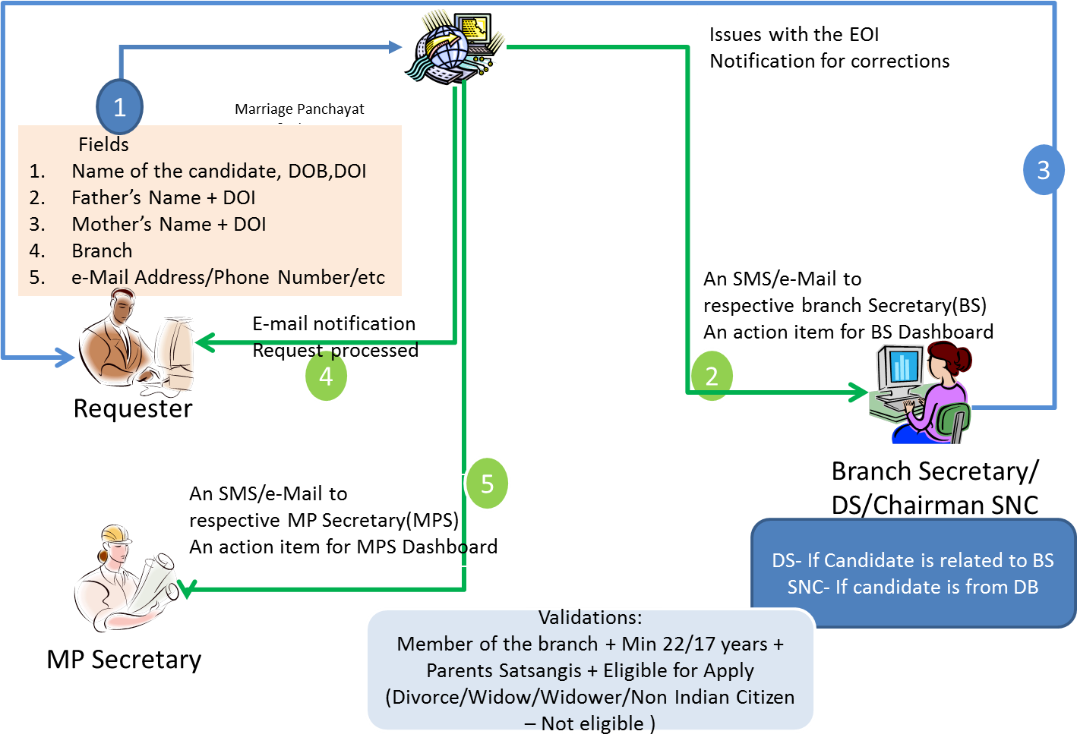

2.1.1.2 Provide Access to RRF: Priority- Essential
An automated email with Username and Password will be sent by the system for providing the access to the validated requester after Status update to “Access Granted” by BS/DS/SNC Chairman. At any point of time the branch Secretary can revoke the access.
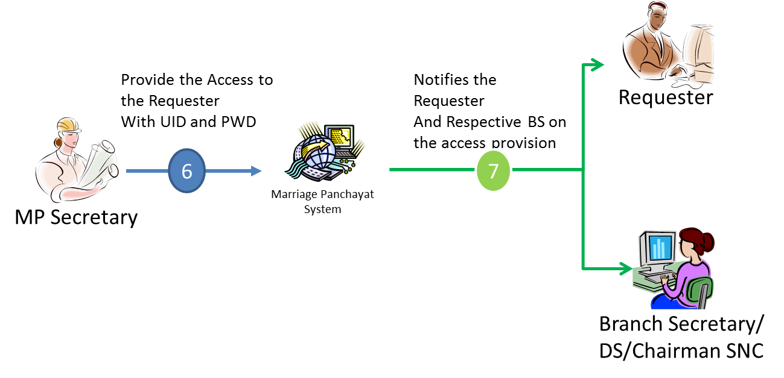
2.1.1.3 RRF Form Filling: Priority- Essential
After successful candidate’s Login into DMPS,

The requester has to complete the checklist regarding the completion of basic below action items:
- Study of Bachans
- Counseling Points
- Rules and Guidelines
- Declaration of willing to follow

After the declaration, the requester can fill Online RRF which will include the required details such as Personal details, Employment Details, Seva details, Family details, letter of consent from non-initiated parents

All the details represented in Current Hard copy form of RRF will be included in the Online RRF. For the fields required to have a proof of documentation, an ability to attach the document will be provided

To complete the Online RRF form, the signatures of Parents/Guardians/candidate have to be filled in the presence of Branch Secretary. BS/DS is responsible for the details filled by the candidate i.e. age, salary, official address etc.

After the formal sign-off by the Parents/Guardians/candidate, an automatic notification will be initiated by the DBMP and sent to the BS/DS.

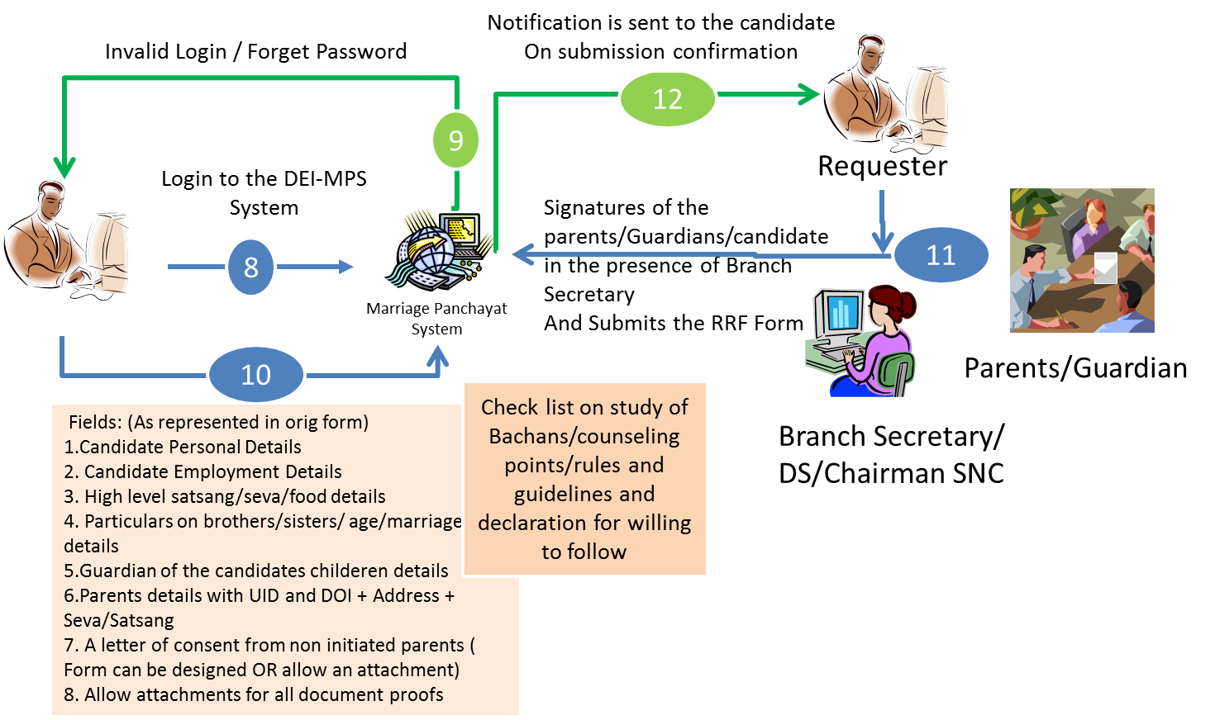

2.1.1.4 Remarks by Branch Secretary/District Secretary/Chairman SNC
Priority- Essential
After the basic validation of the candidate’s data available, the branch secretary provides the confidential feedback on the candidate and parents where the candidate and parent is performing Satsang /Seva for past 3 months and respective details as per the form and confirms/forwards to DBMP Secretary.

The DBMP system automatically sends notification to Candidate and the DBMP Secretary after BS review submission.
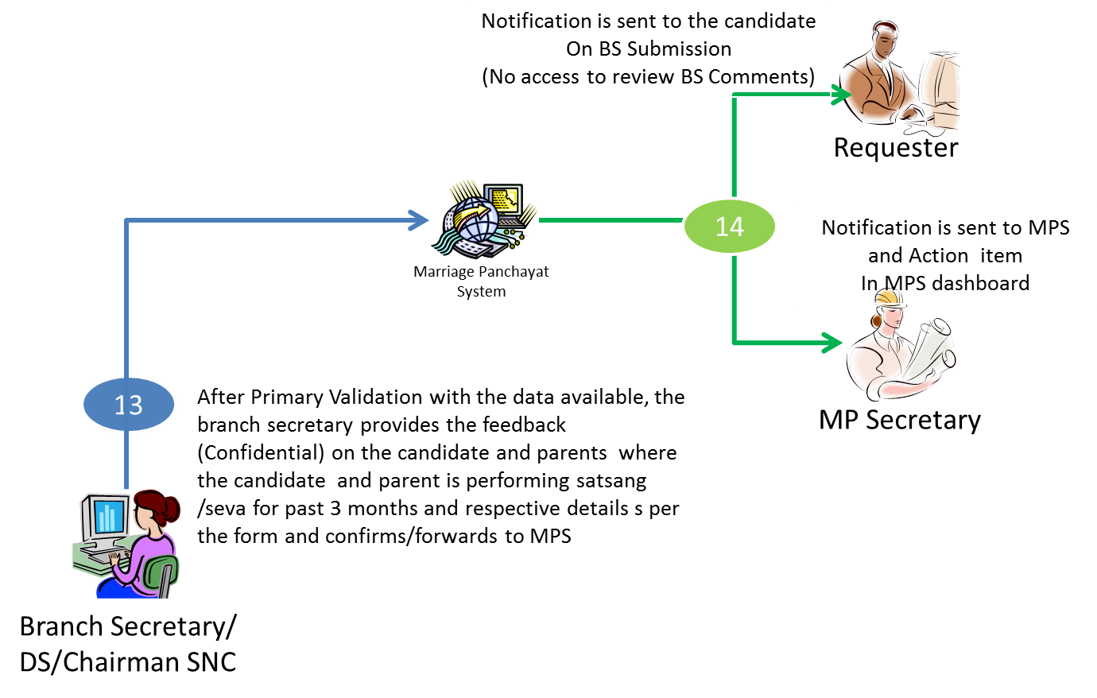

2.1.1.5 Additional Remarks by Candidate’s BS Priority- Essential
(If the candidate and parents are living separately)

If candidate is living in some other branch (other than parent’s branch) additional remarks will be asked from that branch’s Secretary for the past 3 months Satsang and Seva details by the system automatically.

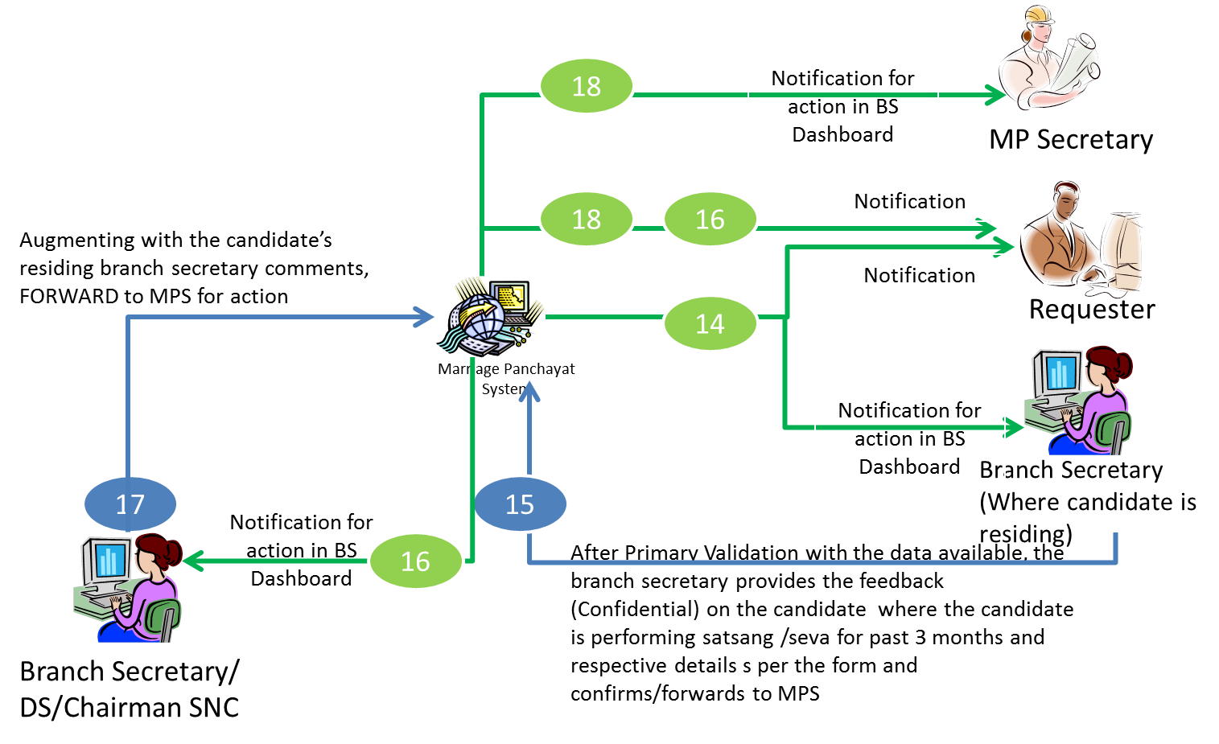

2.1.1.6 RRF Verification Priority- Essential

After discussing with the DBMP President, the DBMP Secretary may reject the Online RRF or request for additional information from the candidate by sending a notification to the candidate and to the respective BS, for any additional queries.
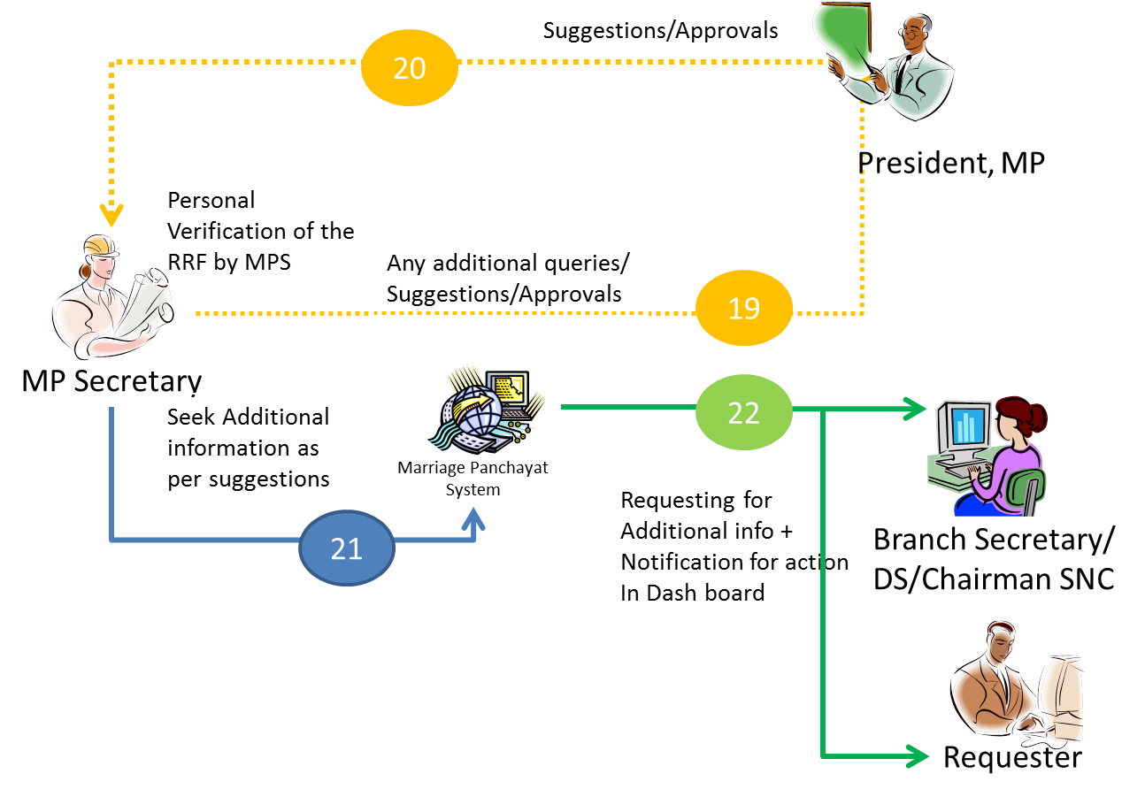
In case of no additional queries are required, the DBMP Secretary, may notify the candidate and to the respective BS, for counselling and further registration process i.e. Online RF.
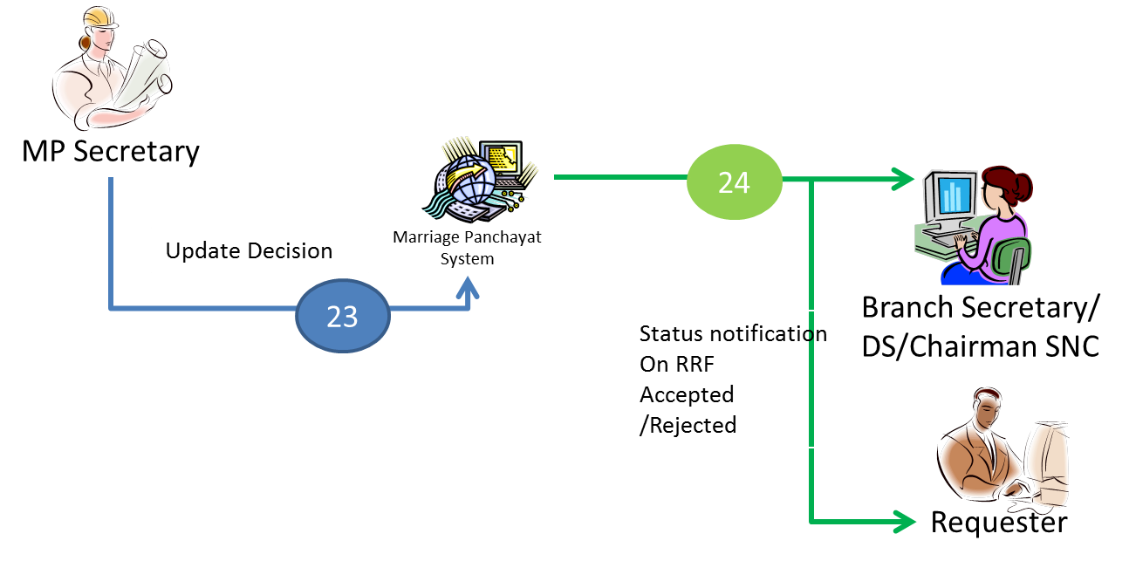

Functional Requirement 2 - < Registration Process> Priority- Essential

2.1.2.1 First Counseling: Priority- Essential
A face to face interaction will be organized between Counsellers (atleast three persons will do the counseling), Requester, Parents/Guardian. It can be done using Video Conferencing (Video conferencing system is not part of this system right now)

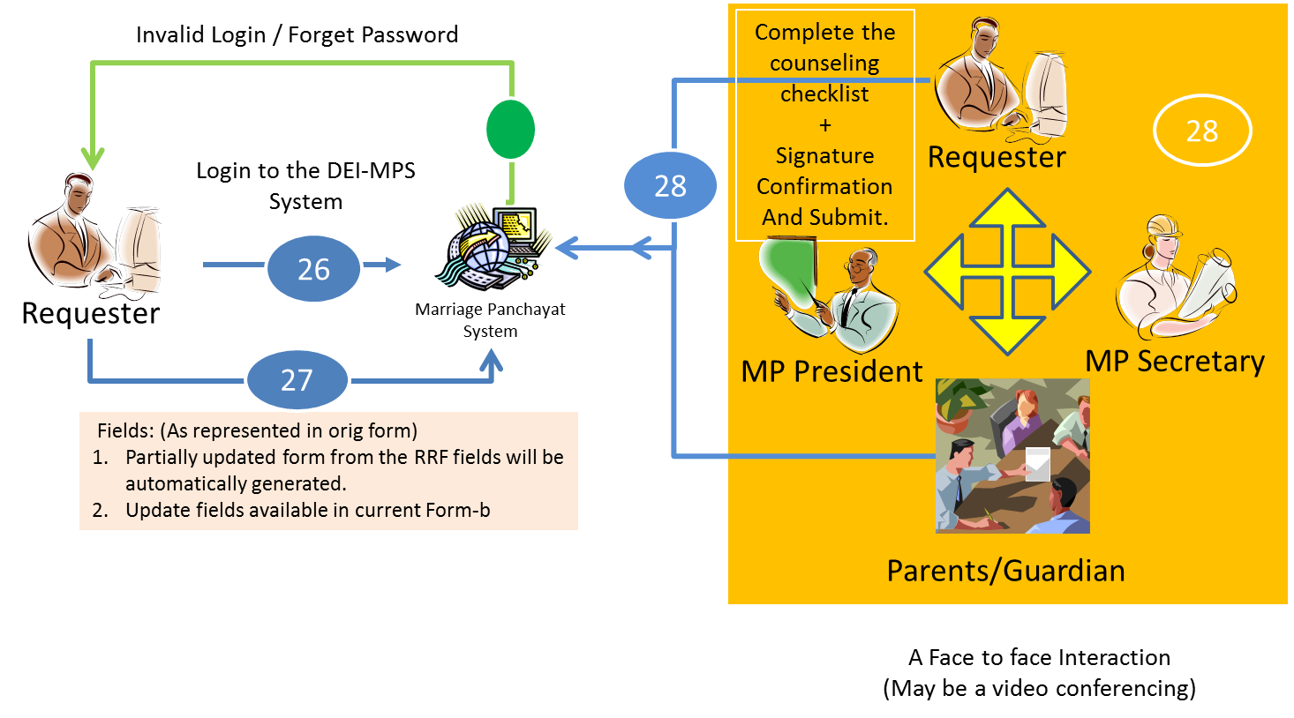

2.1.2.2 Online RF Access: Priority- Essential

After successful first counselling DBMP Secretary updates the System with the details of first counselling and provides access to Online Registration Form (RF) to the requester and sends notification to the requester, BS/DS/Chairman SNC about the first counselling details and access to the Online RF.

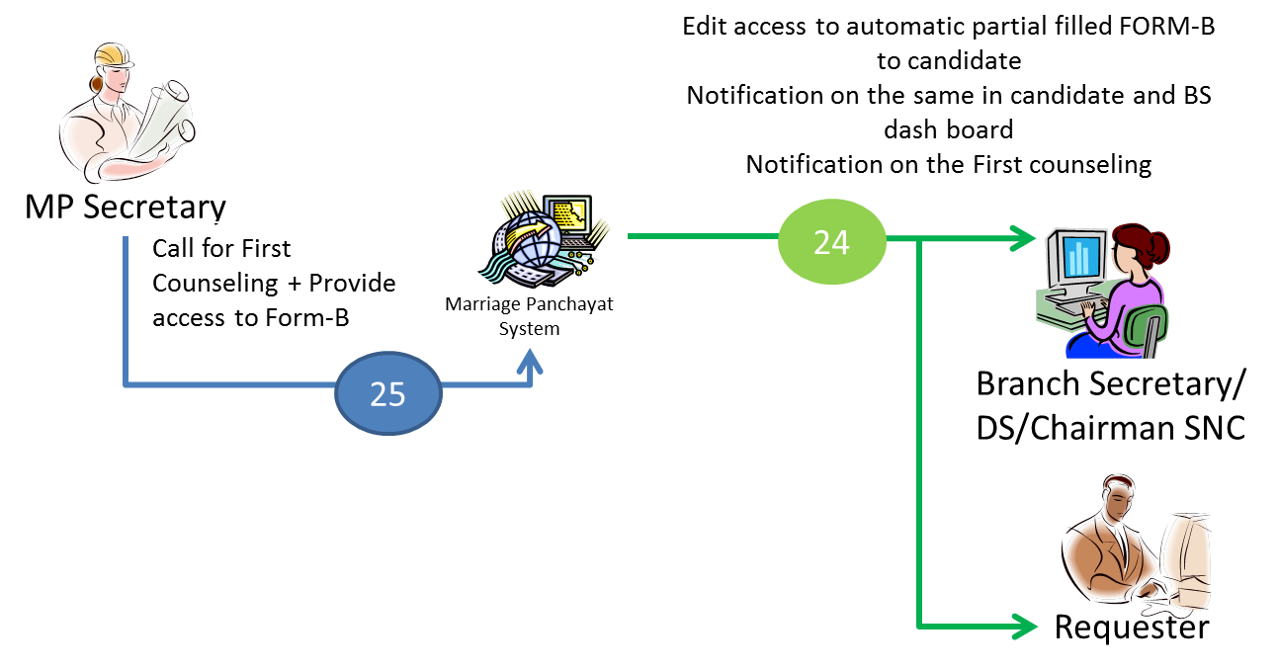

2.1.2.2 Online RF Filling Process: Priority- Essential
Candidate is allowed to fill the partially updated form (from Online RRF submitted), and update the fields available in RF after login into the system. This form will have the option to upload candidate’s photo.

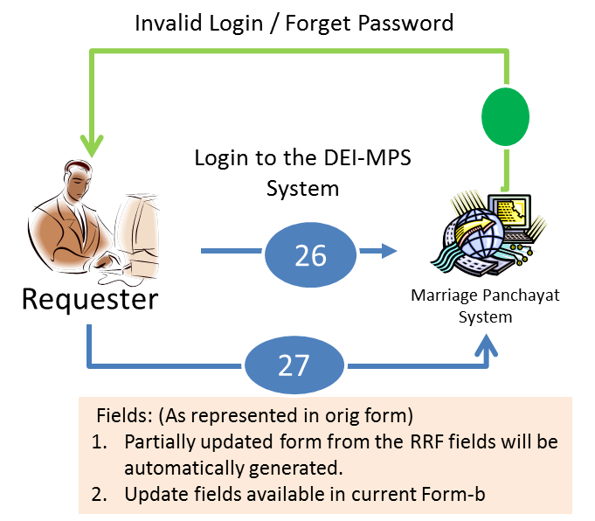

2.1.2.4 Additional Feedback from the BS Priority- Essential

If the original RRF submission date is greater than 3 months then confidential feedback/approval is required from Home Town Branch Secretary and Branch Secretary where candidate is residing.

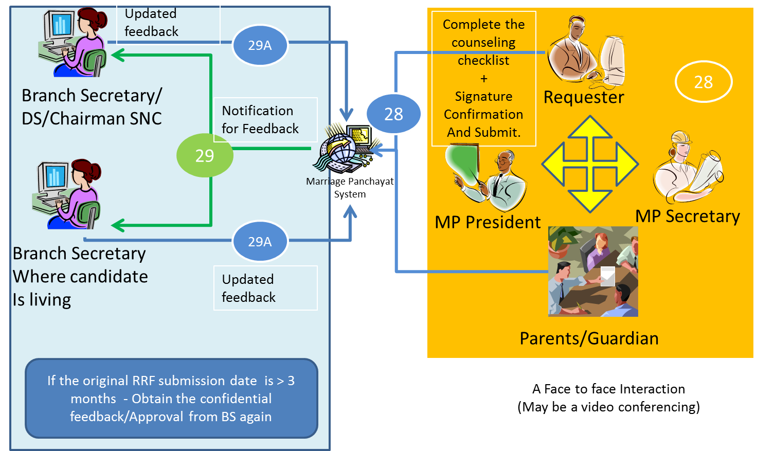

2.1.2.5 Registration Approval: Priority- Essential

DBMP President/Secretary confirms the Acceptance and records the Registration date as Current Date and notify the requester.

It will facilitate user to view candidates profile by other registered and non-registered users.

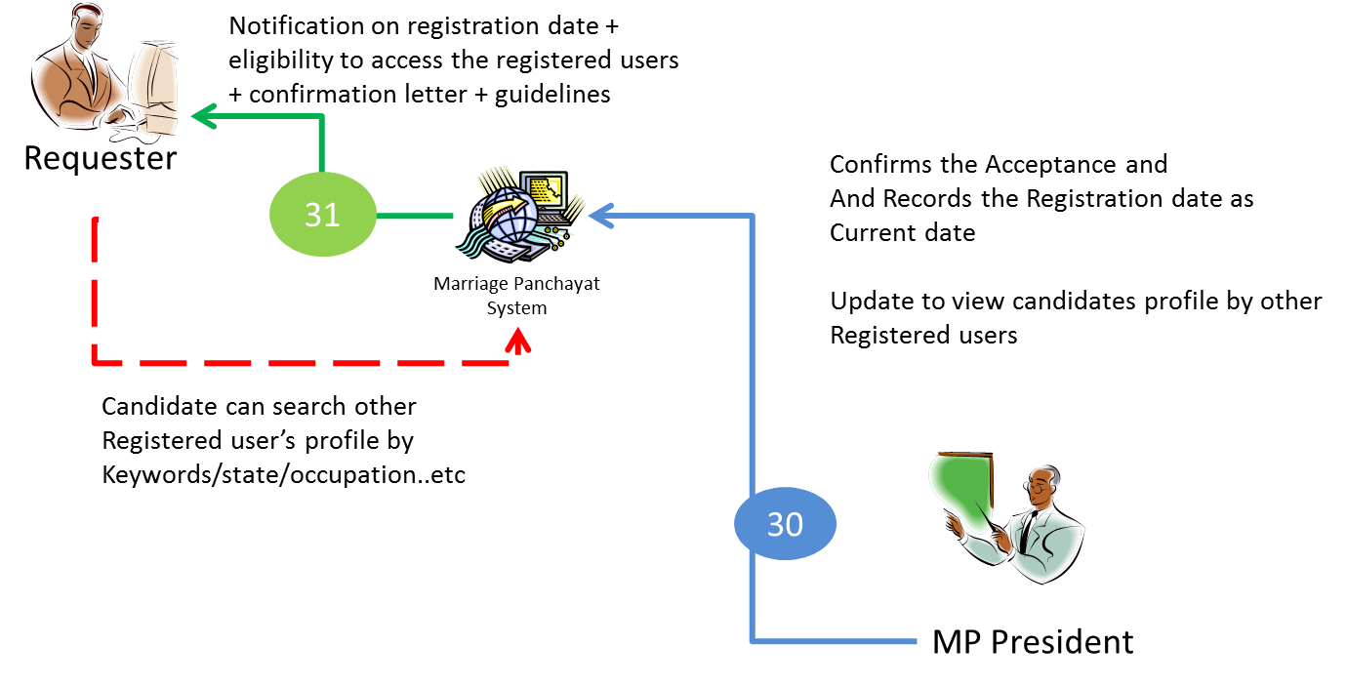

DBMP System allows requester to search candidates profile on various filter criteria such as state/occupation/qualification etc.

Functional Requirement 3 - < Search Process> Priority- Essential

2.1.3.1 Manual Search Priority- Essential
Manual Search facility will be available to all users who have got the login access to DBMP System i.e. after EOI approval.

DBMP System allows the requester to search candidate profile on various filter criteria such as State, Occupation, Qualification, Salary, etc

2.1.3.2 Auto Suggestion Priority- Low
Suggestion for possible alliance based on candidate’s profile and preference will be auto-calculated using advanced algorithms by the system and will be visible to the candidates after login.

Functional Requirement 4 - <Counseling and Marriage >
Following steps are involved in Counseling and Marriage.
- Second Counseling
- Third Counseling
- Fourth Counseling(if required)
- Marriage Proceedings

2.1.4.1 Second Counseling: Priority- Essential
When a party completes his/her search for bride or bridegroom. Both parties will give or send a written consent that they wants to marry through DBMP through a predefined Consent Letter Format.
After receiving consent letter DBMP President/ Secretary may allow the parties for the second counseling.
A face to face interaction via Video Conferencing will take place between MP Secretary, Mp President, Requester, Parents/ Guardian. Requester has to read and accepts the MP guidelines for further processing of the application.
The findings of the Counseling report is attached/ entered into the system
After successful second counseling both the parties move jointly to each other family. Even boy and girl also try to know the others family and their custom without physical relations.
.
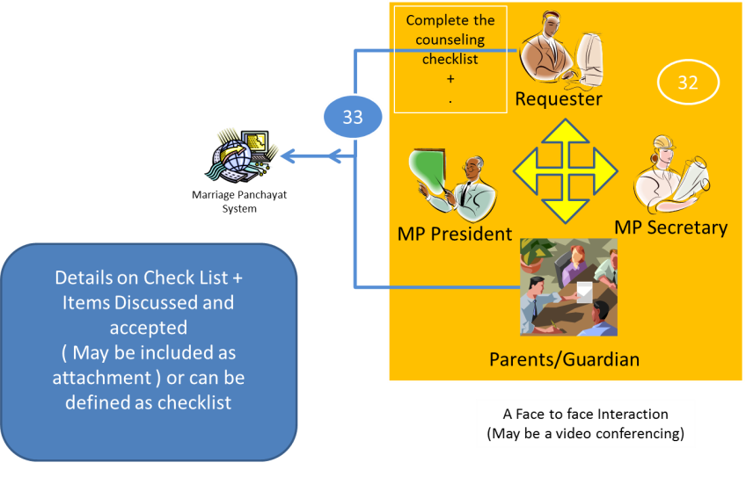

2.1.3.2 Third Counseling Priority- Essential
After atleast two months from second counseling they inform President/Secretary that they are satisfied with others party and prepared for marriage in tentative month. Then they request for 3rd Counseling.
DBMP may be called any member for enquiry then only they allowed for 3rd Counseling date with prior permission of President/Secretary

A face to face interaction will be organized between MP President, MP Secretary, Requester, Parents/Guardian of both parties. It can be done using Video Conferencing.
For successful counseling both the parties should accepts the rules of Marriage Panchayat and should submit Mutual Consent to the Marriage Panchayat System.
The findings of the Counseling report is attached/ entered into the system

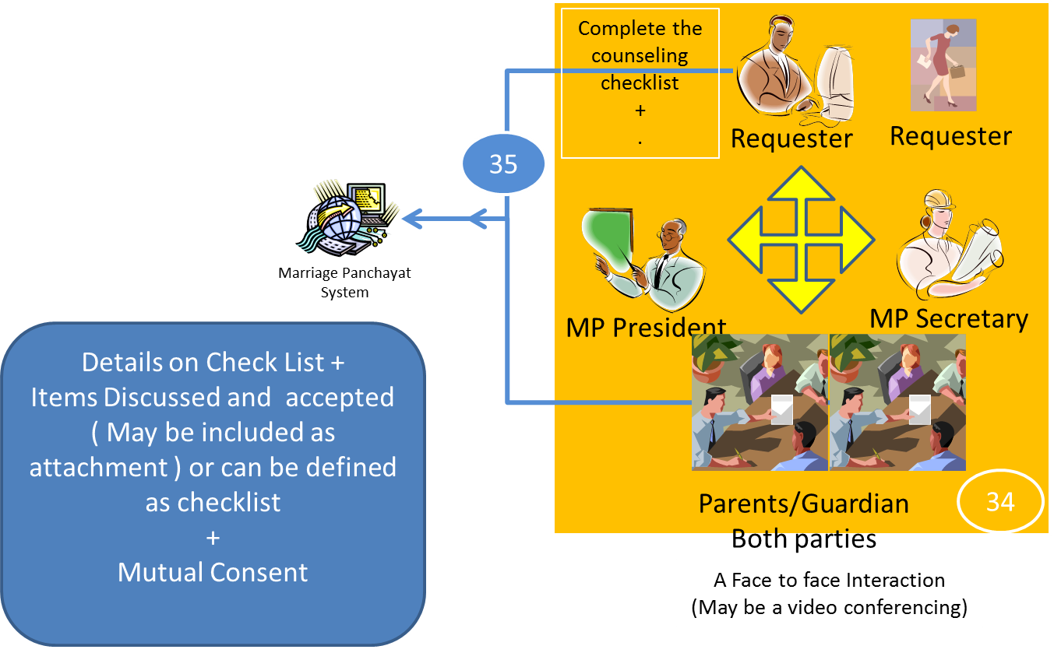

2.1.3.3 Fourth Counseling (If Required) Priority- Essential
It can be done in case of any issues are raised and addressed. This process also can be done by Video Conferencing. The findings of the Counseling report is attached/ entered into the system

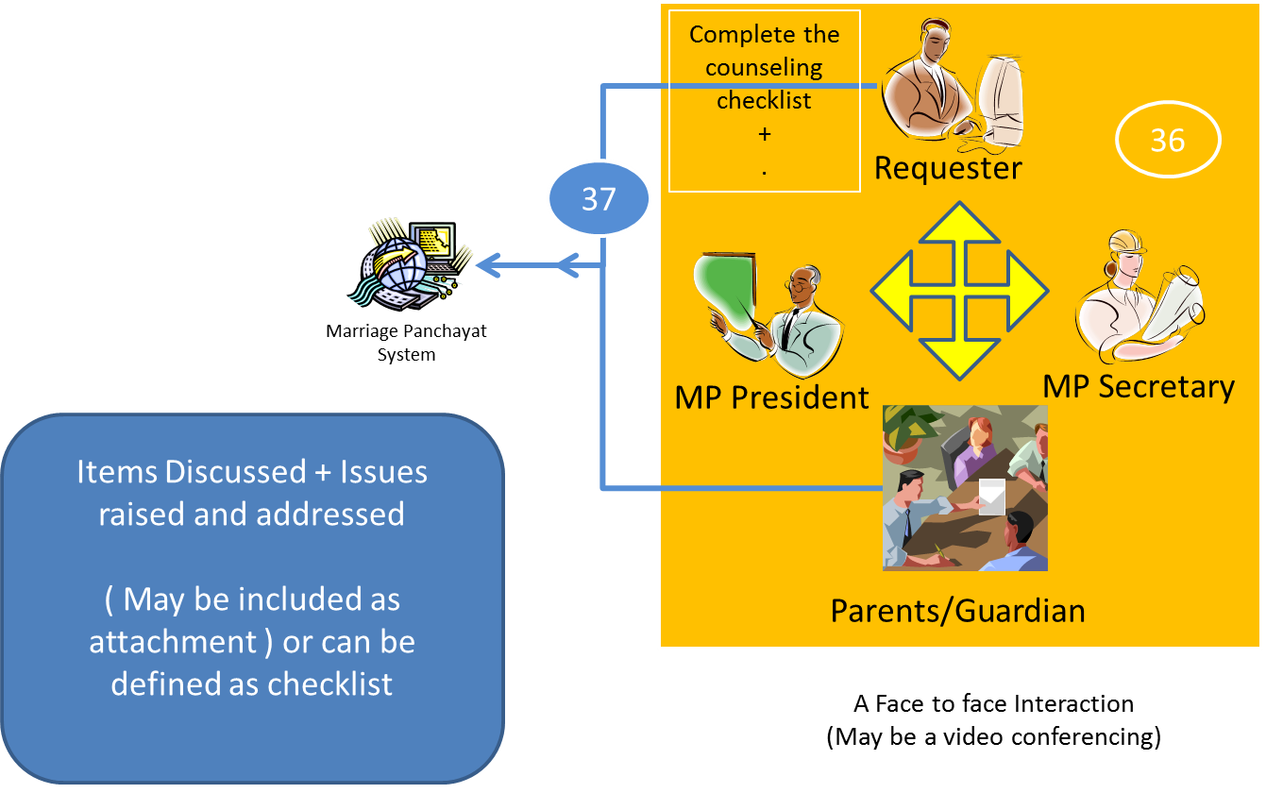
2.1.3.4 Marriage Proceedings Priority- Essential

MP Secretary updates the records on Fixing of Marriage according to the parties tentative month as well as DBMP rules for date of Marriage.

MP System sends the notification of Marriage confirmation to S/DS/Chairman SNC and both the requesters

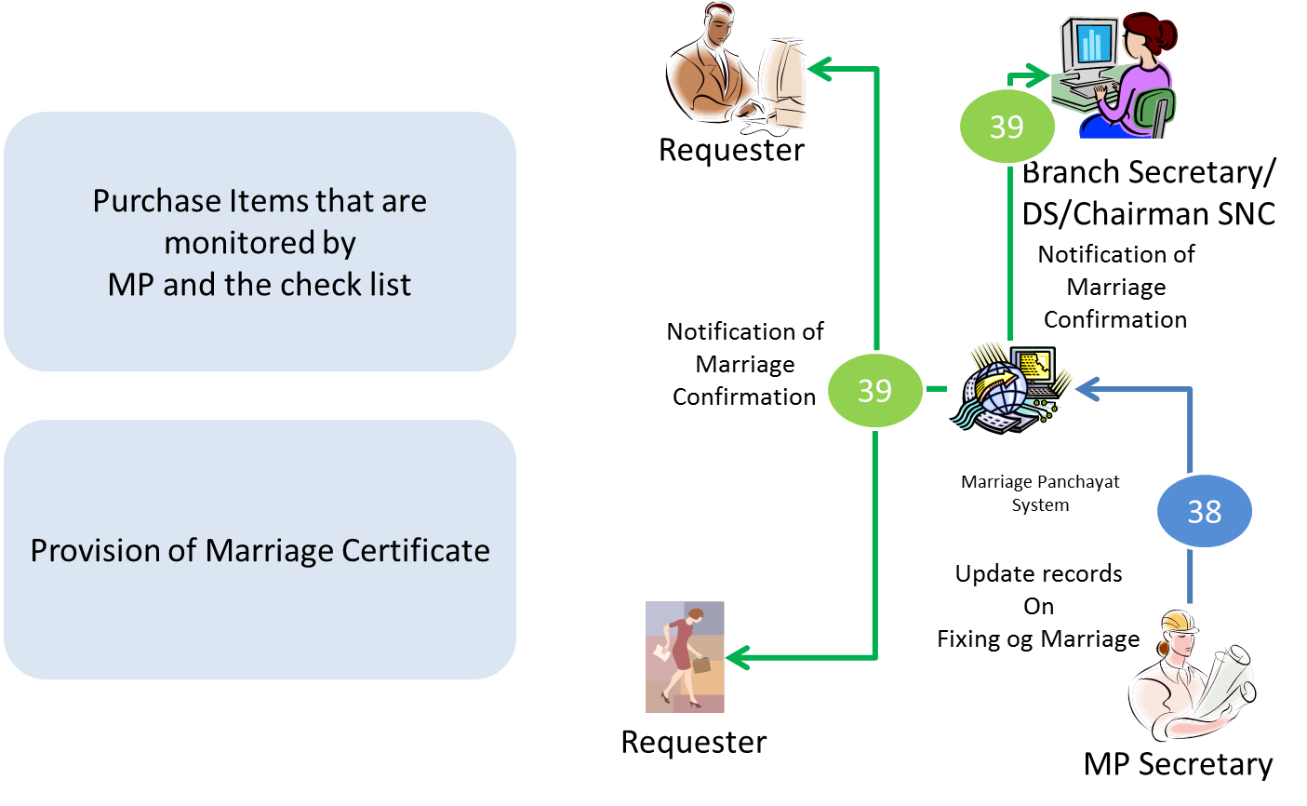

Functional Requirement 4 - <Registration Cancellation>

This process can take place in following two scenarios.

If requester completes the validity of 4 years of registration with the Marriage Panchayat

If Marriage is approved then Automatic Cancellation will be done by the system.

If any requester settled their marriage outside from DBMP then He/she should immediately inform to DBMP Office so that their registration form will be remove from the display.

Marriage Panchayat System sends the cancellation Notification to BS/DS/Chairman SNC, Requester and MP Secretary in both the cases.

. 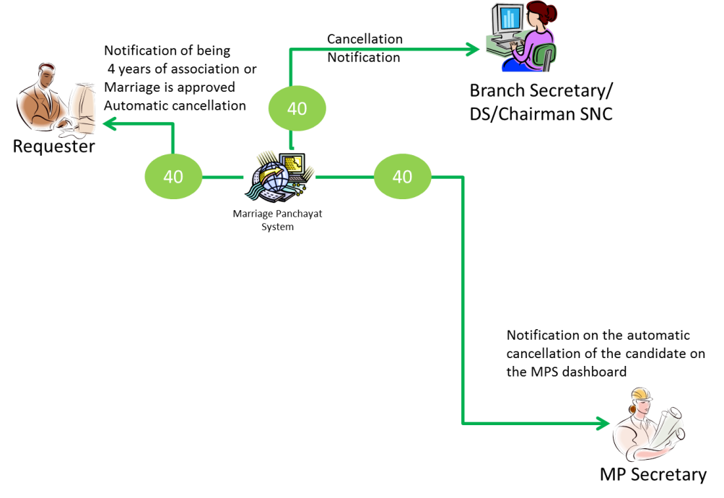

Functional Requirement 5 - <Registration Renewal>

Requester can place a request for the renewal of the registration with justification before 4 years.

DBMP President/Secretary will decide for the extension of old form or filled a sub-form or go through new process.

Requester will get the Accept/Reject notification.

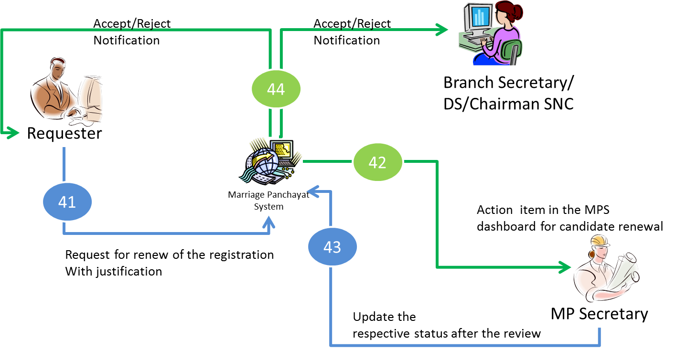

Functional Requirement 6 - <Process Audit and Control>
Generate process audit and control reports.

2.1.10.1 Generate the On-line reports on number of applications received by program
-By Number of Registration and additional details
Priority- Constrained

Functional Requirement 11 - <Business Analytics>
Generate Ad-hoc analytics reports.

2.1.11.1 Generate the On-line reports based on the ad-hoc criteria defined by the marriage panchayat administration team (The details of this requirement needs to be explored before end of the analysis phase)
Priority- Constrained

Non-Function Requirements

Non-Functional Requirement 1 - <Concurrent users>
The system should be capable of supporting 50 concurrent users. Priority- Essential

Non-Functional Requirement 2 - <Availability>
The system should be available 24X7 starting from the first admission notification to the last date. Priority- Essential

Non-Functional Requirement 3 - <Data Security>
To facilitate the data security, retention and recovery, a qualitative image copy of the database server should be maintained. Priority- Essential

Non-Functional Requirement 4 - <Usability Requirements>
The user interface design should consider the users with a minimum computer literacy. Priority- Essential

Acceptance Criteria

Test Requirements
3.1.1.1 Automatic Load, Capacity and Performance test should be conducted to ensure that quality of Service with 50 concurrent users Priority-Essential

System External Interface Requirements
External interface | Input | Outputs | Requirement | Frequency

Report Specifications

2.4.1.1 The report layouts will be provide before end of the analysis phase for valid reports Priority -Essential

Assumptions and Issues

Assumptions –

Issues –

